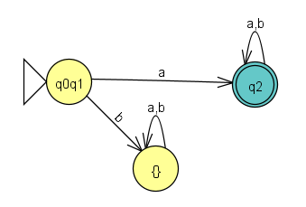

|  |  |  |  |  |
| --- | --- | --- | --- | --- |
|  |  | λ*aλ* | λ*bλ* |  |
| + | q0 | q2 | {} | unionize |
|  | q1 | q2 | {} |
| - | q2 | q2 | q2 |  |
| + | q0q1 | q2 | {} |  |
|  | {} | {} | {} |  |